Uninterruptible Power Quality™
vs.
Backup Power or
Uninterruptible Power Supply

Backup Power vs. Quality Power
While many companies emphasize power backup and only take care of the most severe power problems, Power Innovations focuses on providing quality power to protect today’s electronic equipment and then on providing the needed power backup. We call this new standard Uninterruptible Power Quality™ (UPQ™).

What is UPQ™?
UPQ™ is a new standard that began with traditional Uninterruptible Power Supply (UPS) technologies and moved forward to address critical modern power issues. Traditional UPS systems focus on backup power; UPQ technology focuses primarily on the critical issues of power quality and management, while still providing backup when power outages occur.

What is UPS?
Uninterruptible Power Supply (UPS), also known as a battery backup, is a device which maintains a continuous supply of electric power to connected equipment by supplying power from a separate source when utility power is not available. Before the differences between UPSs and UPQ are discussed, something should be said about the importance of power quality.

Why is quality power important?
Power quality is a major issue today. Superior power quality is essential for today’s sensitive electronic equipment, while at the same time, the power being supplied by utilities and generators is constantly decreasing in quality and availability. Since power demand often exceeds supply – and the gap is widening – there are wide fluctuations in the quality of available power. In many cases the power suppliers have also reduced their standards for power they deliver. Other equipment connected to the same power source can also dramatically reduce the quality of power to sensitive electronic equipment. The result is that it is up to the customer to protect their equipment and insure that it keeps running when power events occur.
UPQ technology incorporates additional features and functions not found in conventional UPS systems. UPQ technology assures perfect power to connected equipment regardless of the quality or source of incoming power. UPQ systems are always online (multi-conversion) and provide many advantages that make them the only choice for today’s applications. To illustrate the difference, the major industry approaches to backup are shown below in order of increasing power quality.
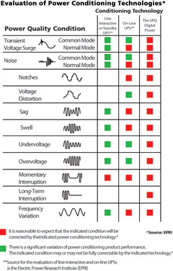
Figure 1: Power Quality Issues

What are the major industry approaches?
- Standby UPS – The simplest backup system is a traditional standby UPS. Standby systems have no power cleaning. The power comes from the AC source until power fails and a switch engages a battery-powered inverter to produce power. The inverters commonly used in devises under 4kW are often of low quality and produce a modified square wave. This resulting poor power quality can damage connected equipment. The power flow in a Standby UPS is shown below.

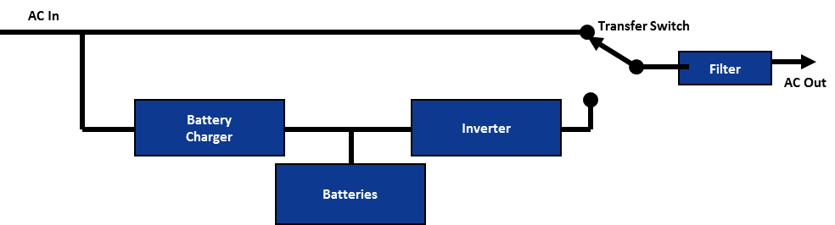
Figure 2: Standby UPS

- Ferro-resonant UPS - Ferro-resonant UPSs operate in the same way as a standby UPS unit, with the exception that a Ferro-resonant transformer is used to filter the output. This transformer is designed to hold energy long enough to cover most of the time between switching from line power to battery power. The energy does decrease as time progresses. As with a Standby UPS, there is typically no power cleaning when the input AC power is available. The inverters are commonly of low quality and produce a modified square wave. The transformer may or may not be an isolation transformer but the Ferro-resonant transformer does reduce the energy drop during transfer to inverter.

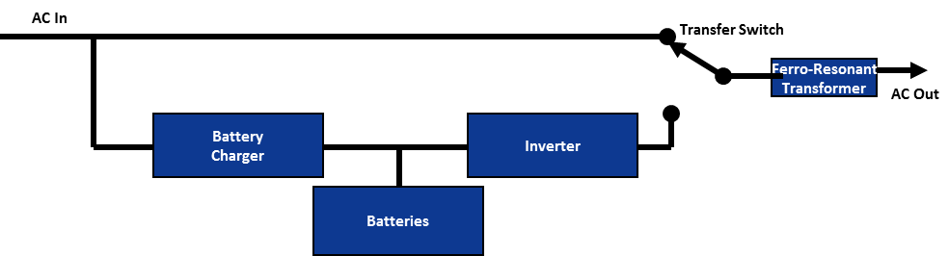
Figure 3: Ferro-resonant UPS

- Line-Interactive UPS – The next step up is called a line-interactive UPS. These systems are similar to standby systems but provide a voltage increase (boost) or decrease (buck) without accessing the batteries when power dips or increases slightly. Some line-interactive units provide minimal protection from power spikes and surges. A diagram of a line-interactive UPS can be seen below.
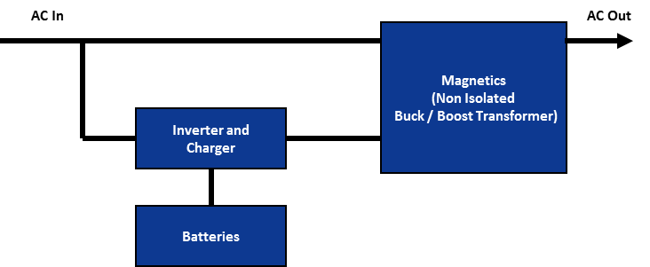

Figure 4: Line-Interactive UPS

- Traditional On-Line UPS – An on-line UPS uses a double-conversion process that isolates utility power. The UPS takes the incoming AC power, turns it into DC power and then re-generates AC power through a conversion process. The process eliminates noise, sags and surges before converting the power back to AC. The inverter is always on-line so there is no transfer or switching time to battery mode in the event of a power failure. The quality of an on-line system is highly dependent on the quality of the inverter used to turn the DC power back into AC power. Lower wattage units typically have lower quality wave forms, and higher wattage units have better wave forms.

- Five-Stage Conversion UPQ™ – Power Innovations takes the on-line UPS to the next level of quality. Power Innovations’ Uninterruptable Power Quality™ (UPQ™) systems use the company’s signature five stages of conversion and isolation to provide the cleanest power available. UPQ™ systems regulate and filter incoming power as well as provide battery backup. The five stages are shown in the diagram below and include:
- Stage 1: Input EMI and suppression filters
- Stage 2: AC to DC rectifier
- Stage 3: DC to DC regulator and battery charging circuitry
- Stage 4: DC to AC inverter
- Stage 5: Output EMI and suppression filters

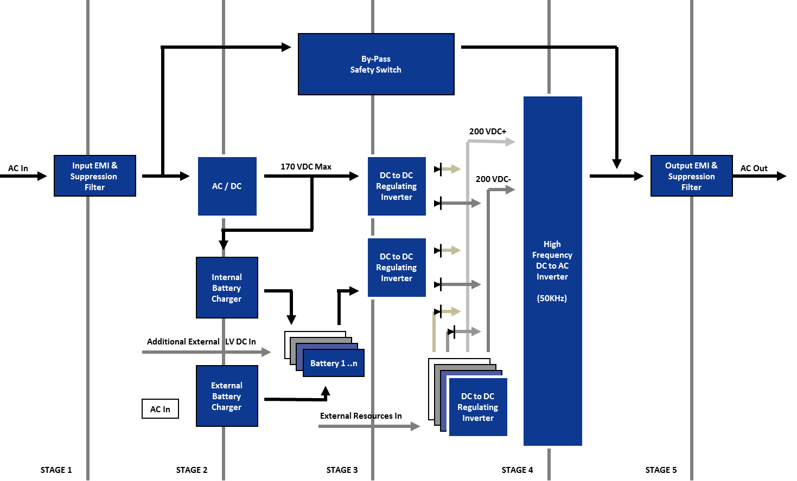
Figure 5: Q-Series – 5-Stage Conversion

UPQ Features

Always Online
UPQ systems are always online and feature superior isolation and/or conversion, creating a new standard for power quality and exceptional reliability. In comparison, standby and line-interactive UPS systems merely filter input utility power, and online UPS systems have double conversion (two stages) technology.

Five Stages of Isolation and Conversion
UPQ technology provides multiple levels of isolation and/or conversion, five (5) stages. In comparison, traditional UPS online systems provide only double conversion, two (2) stages.

Superior Level of Output Power Quality
UPQ systems deliver the highest quality of regulated clean, pure, filtered power, regardless of the quality of the input power, utilizing multi-stage conversion technology and advanced isolation.

Accept a Wider Range of Input Power
UPQ systems accept a wider range of input power variation (up to double that of traditional UPS systems) before utilizing batteries.

Quality Power With or Without Batteries
UPQ systems operate whether or not batteries are connected. Without batteries, UPQ systems become regulation, conditioning, filtering, and conversion units that continue to manage and regulate a wide range of input power deviation.

No Adverse Effect on Surrounding Equipment
- UPQ systems minimize induced input harmonics and upstream power problems to equipment not connected to the UPQ system (low input distortion). Traditional UPS systems can inject high levels of harmonics onto the utility feed lines and increase power quality problems to equipment not isolated or connected to the UPS output.
- Through the use of inrush current management technology, UPQ systems minimize inrush current, reduce stress on upstream circuits and equipment, as well as reduce the need for oversized systems or generators.

Advanced Management and Control
UPQ systems can be controlled from within a network operations center, via an Internet connection, and from handheld wireless devices, such as PDAs and cell phones. Simple Network Management Protocol (SNMP) enables Internet access to real-time power status and history reports. Flexible interface, environmental monitoring, and security management capabilities are available.

Distinct Cost Savings
UPQ systems provide long-term direct and indirect cost savings. UPQ systems:
- Supply perfect quality power and prevent damage to connected equipment, which extends the life of the equipment being protected
- Have longer battery life, which decreases battery replacement costs and equates to substantial savings over time, especially on larger systems
- Have longer system life with a “mean time between failure” (MTBF) of over 175,000 hours, meaning that UPQ systems last substantially longer than ordinary UPS systems before service and / or replacement is necessary
- Provide higher operating efficiencies that require less utility power
- Generate less heat, which reduces air conditioning costs

Models Available for Specific Applications
- Rugged applications requiring 30Gs of gravitational force in X,Y, and Z planes, with temperature ratings to -22°F (-30°C) and above 140°F (60°C)
- Compliant as components in ATEX Zone 2 applications for operation in potentially explosive environments

Options
- Custom input and output voltages and frequencies
- User specified input and output plugs/terminal strips
- Custom power distribution units (PDUs)
- Rack front loadable

